*Link dos protótipos de design do TCC*

Protótipo do site Litch Group (Equpe do TCC):

<https://www.figma.com/file/D93xrnpcgvXZpJLS2idpXy/Design-Landing-Page---Litch-Group?type=design&t=rpzamyjxGwjuezSt-1>

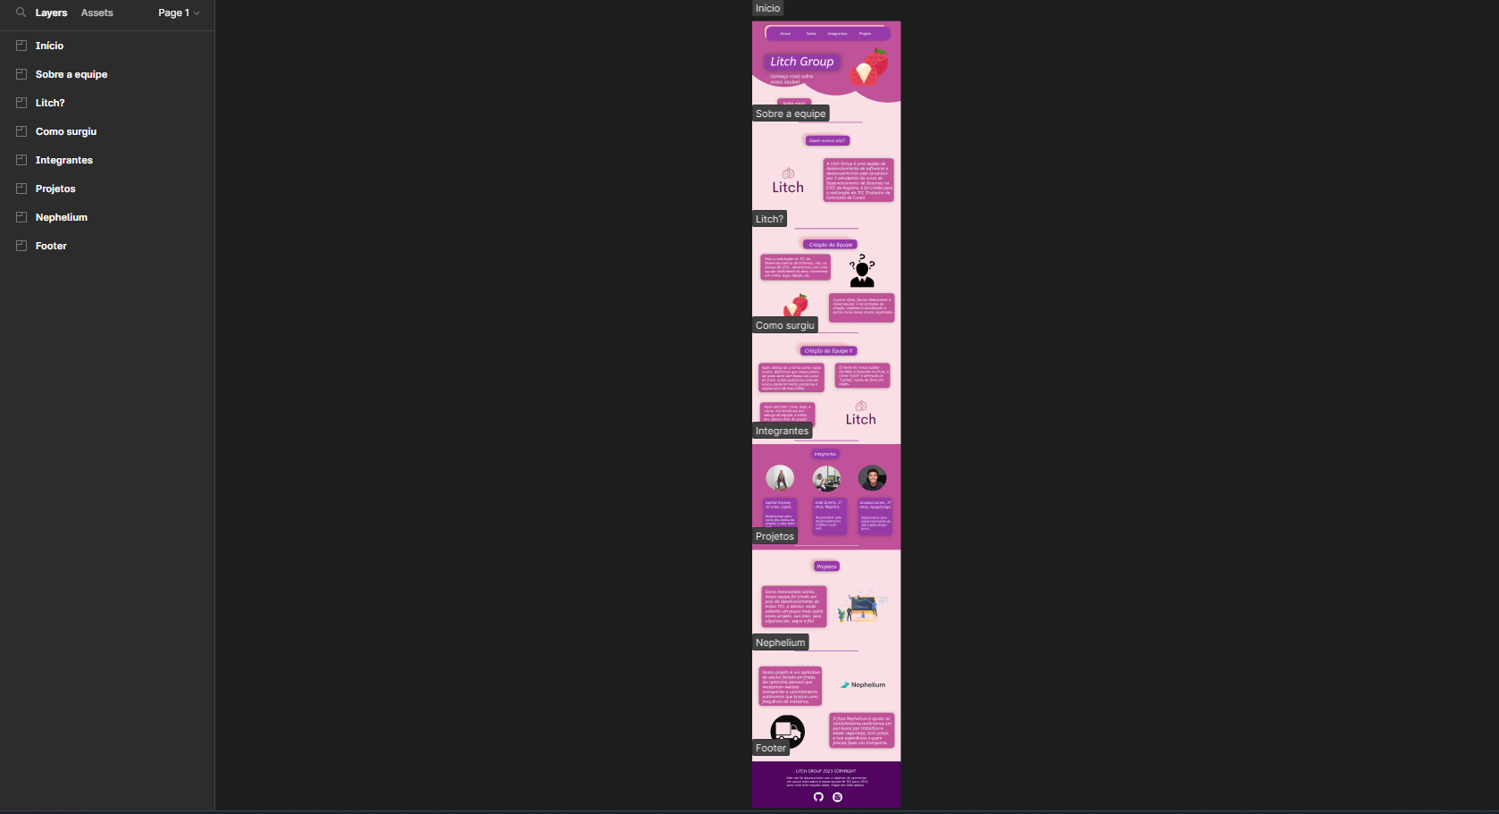

Protótipo do APP Nephelium:

<https://www.figma.com/file/BbupkFFxg52AfQKWRXrN6X/Nephelium-Prototype?type=design&node-id=0%3A1&t=rpzamyjxGwjuezSt-1>

